Access Specifier’s in Java?



**What is access Specifier’s?**

The methods and instance variables are known as **Member’s.**

The access specifiers also determine which data members of a class can be accessed by other data members of classes or packages etc. To ensure encapsulation and reusability, these access specifiers/modifiers are an integral part of object-oriented programming.

**There are two types of Modifier’s in Java:**

1. **Access Modifier’s**

* This allow us to set the scope or accessibility of data member’s.

1. **Non-Access Modifier’s**

* This are used with classes, variable’s, methods, and constructor.
* This are define the behavior of entities to JVM.

1. **Access Modifier’s**

Types:->

1. **Public:** Public means this entity can accessible within class, package also accessible out side of class and package as well.
2. **Private:** this entity only accessible within the class only.
3. **Protected:** this entity accessible by outside class also by extending the Protected class.
4. **Default:** whenever access modifier’s are not specified then it is assumed as Default.
5. **Non-Access Modifier’s**

Java also provides non-access specifiers that are used with classes, variables, methods, constructors, etc. The non-access specifiers/modifiers define the behavior of the entities to the JVM.

**Some of the non-access specifiers/modifiers in Java are:**

* static
* final
* abstract
* transient
* volatile
* synchronized
* native

Example’s:

01]. Public Access Modifier:

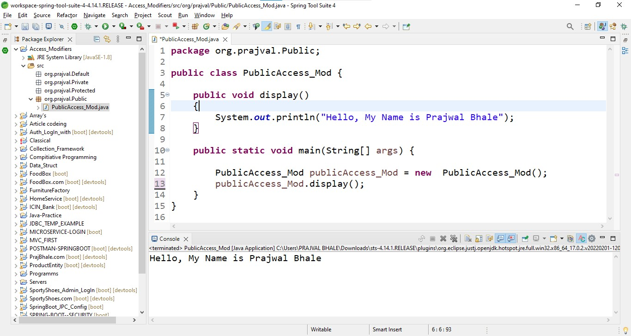

02]. Private Access Modifier:

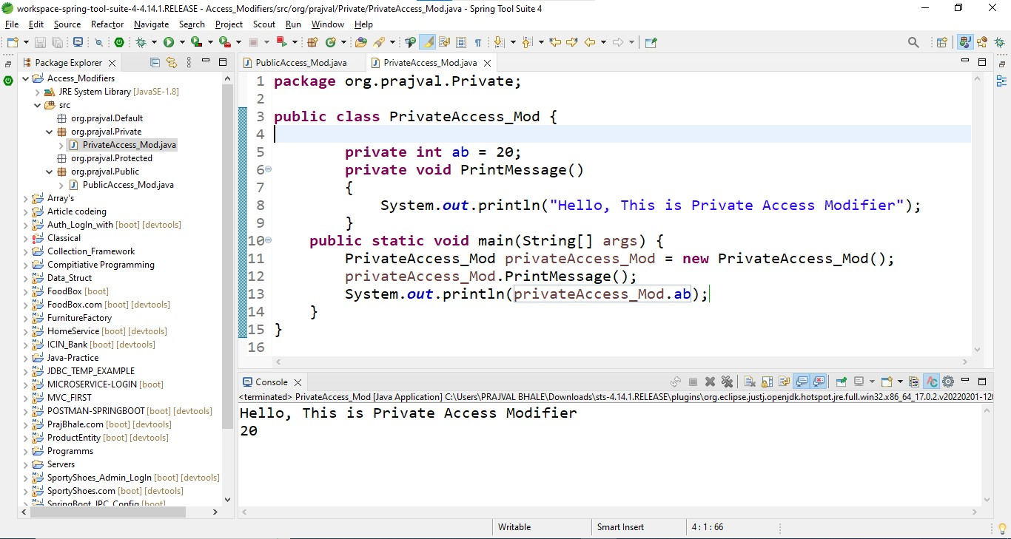

Here I’m create one example with Getter and Setter’s.

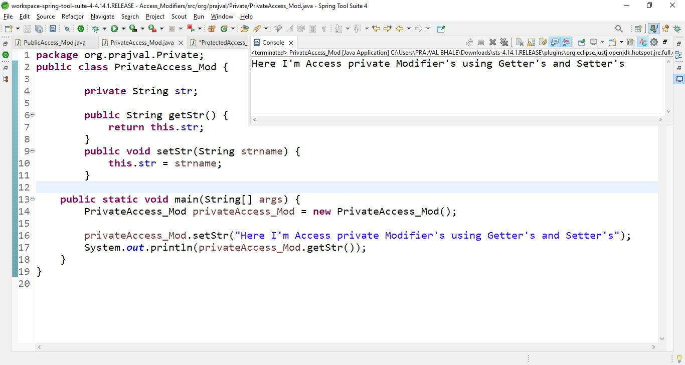

03]. Protected Access Modifier:

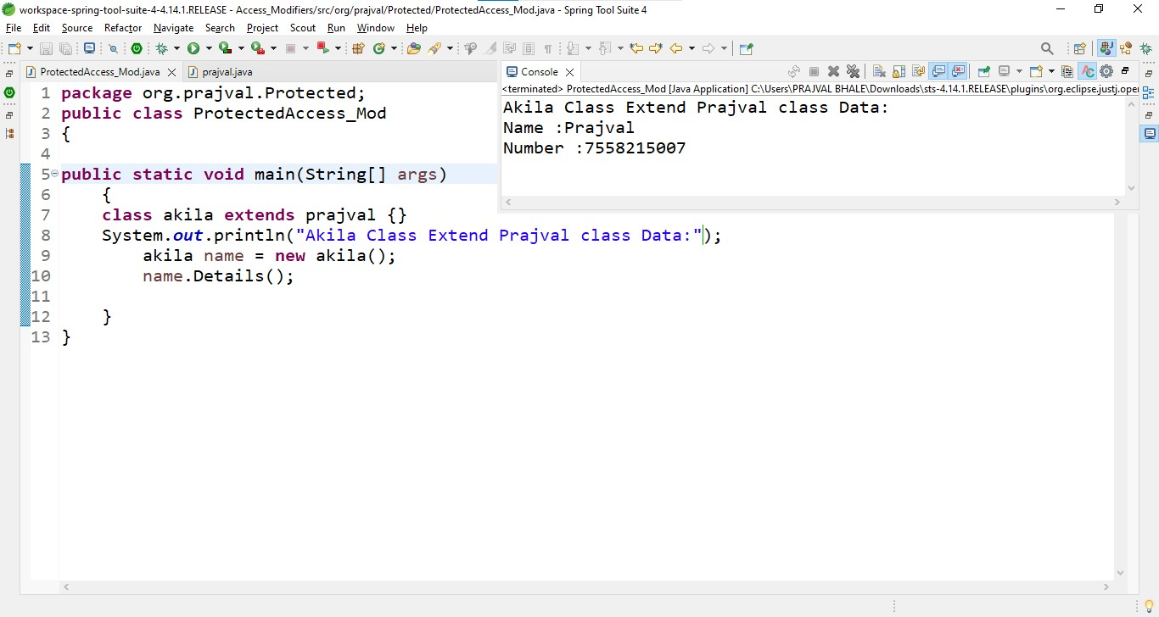

Extra Class for Protected Modifier:

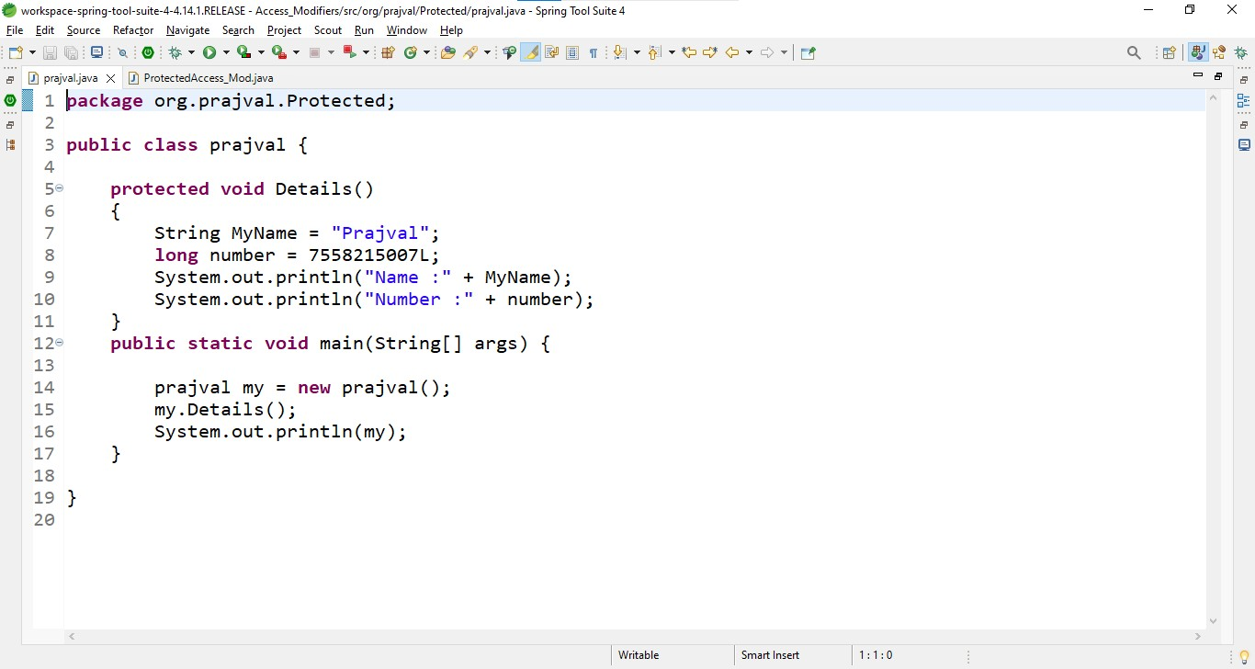

04]. Default Access Modifier:

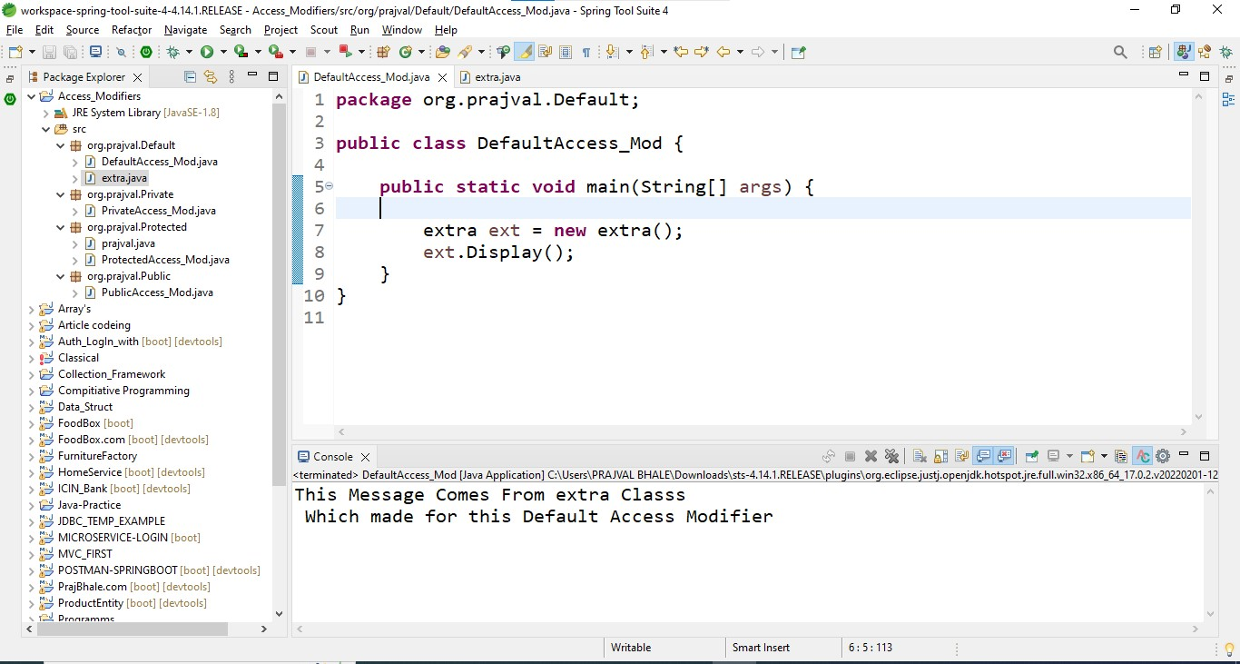

Extra class for Default Modifier

